Hey Bro,
If you think you have a solution, it would be really good to achieve this today, after all out pitfalls. Its imperative we lock down a solution for the layout of a section and all design elements sit in on.
Shall we have a go at fixing it now?
Here are my observations and our misunderstanding of our goal, going through this a number of times at expensive cost. The first thing is we didn’t have the full top level down of the structure. This is strapi backend where we always start out, our very first though process has to consider the data, fields, options etc and how its structured and customisation for each component. Because if we don’t understand that we will always be running around in circles on the frontend, hence our problems
Strapi, built for content managers to have true ownership of their content to build pages with provided structure. But I want to go a step further, than just the control of build pages in strapi admin. I want them to true control on how the present that data, by providing creative relations and style customisations to fields components etc giving granulise control of look and feel in how to style and display components, and dynamic behaviour via relations
Large title, gradients, two tone styles on titles spacing large normal tight. Giving the user more than just the ability to build pages but style the components that are consistent through break points, utilising strapi to its fullest potential, in terms of giving content managers more control to customise the look and feel of pages the build via the options feature on fields.
Evolution: Atomic Design
Steps taken to achieve our gaol, shared component in strapi to have reusable smaller component to creatively build out our sections, respecting deep level nesting, documented, and if we done enough re-structuring to fully utilis Atomic Design for our strapi backend
An Atomic Design folder structure organizes components into five levels: atoms (smallest elements like buttons), molecules (combinations of atoms like form fields), organisms (larger sections like a navigation bar), templates (page layouts without data), and pages (full-page views with real content). This hierarchical structure allows for modular, reusable UI development by building from simple to complex parts.
Example folder structure
src/
├── components/
│ ├── atoms/
│ │ ├── Button/
│ │ ├── Input/
│ │ └── Label/
│ ├── molecules/
│ │ ├── FormField/ // (e.g., Input + Label)
│ │ └── SearchBar/ // (e.g., Input + Button)
│ └── organisms/
│ ├── Header/
│ └── Navigation/
├── templates/
│ ├── ArticleTemplate/
│ └── ProductListTemplate/
└── pages/
├── HomePage/
└── ProductPage/

Breakdown of levels
- Atoms: The most basic building blocks, such as buttons, inputs, and labels.
- Molecules: Groups of atoms that form simple components, like a search bar made of an input and a button.
- Organisms: More complex components composed of molecules and/or atoms, such as a site header or a footer.
- Templates: Page-level structures that arrange organisms and molecules to define layout and content structure, but use placeholder data.
Pages: The final, fully-realized instances of templates with real content applied, demonstrating the final user interface.

Structure:
Section: backgroundStyle – think about renaming to section for clarity, or a better name?
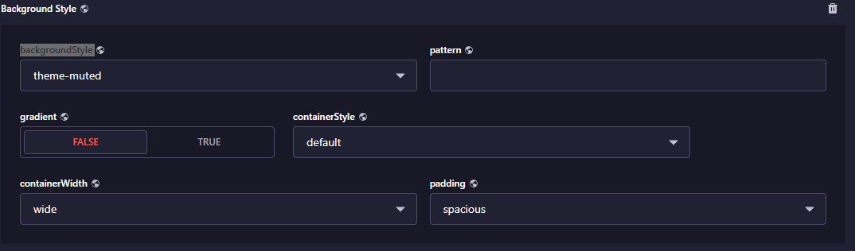
1: default spacing horizontal and vertical for custom components with similar pattern
Section components:
containerStyle: default spacing
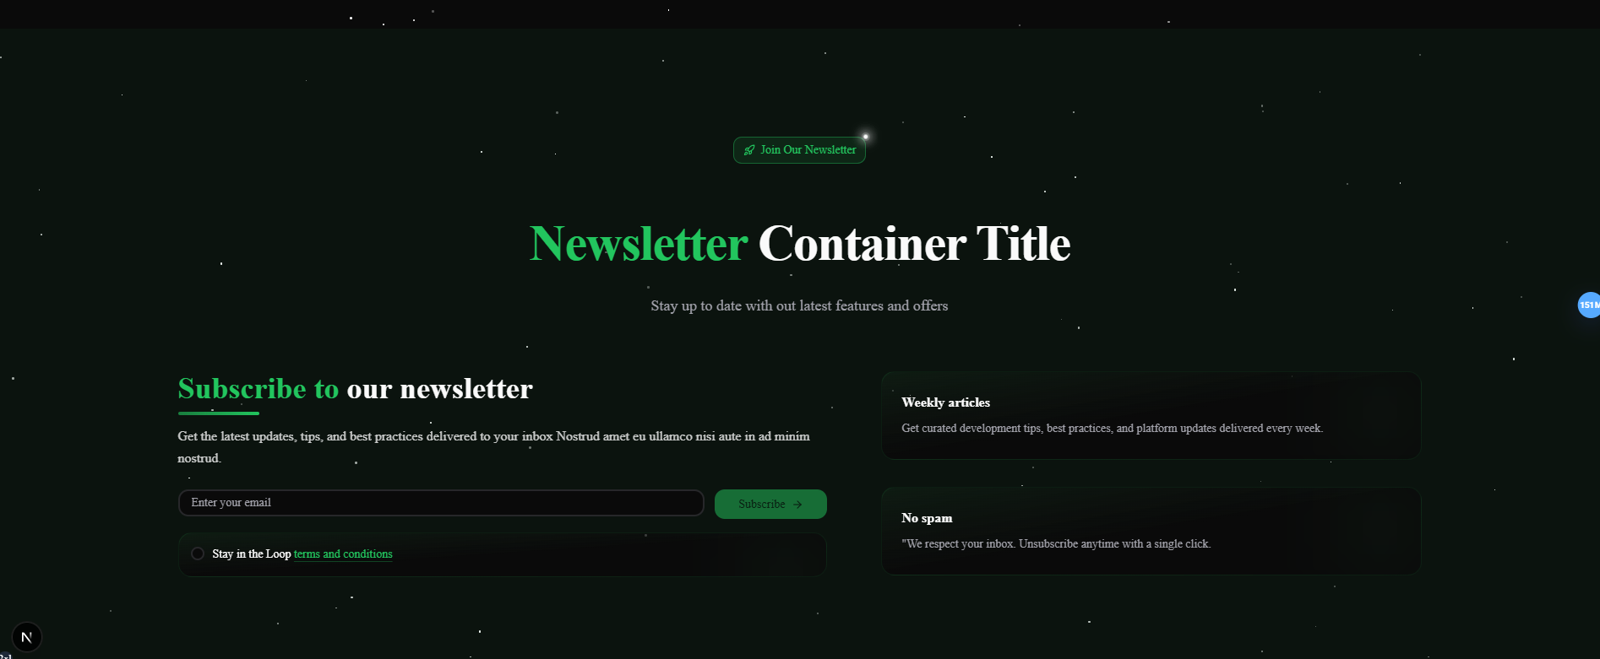

Section components Layout:
- Badge
- Section Heading
- Description
- Component

2: Section: backgroundStyle – think about renaming to section for clarity, or a better name?
Has a style containerStyle – that wraps the Section components in a container for customisation
- containerStyle: boardered spacing
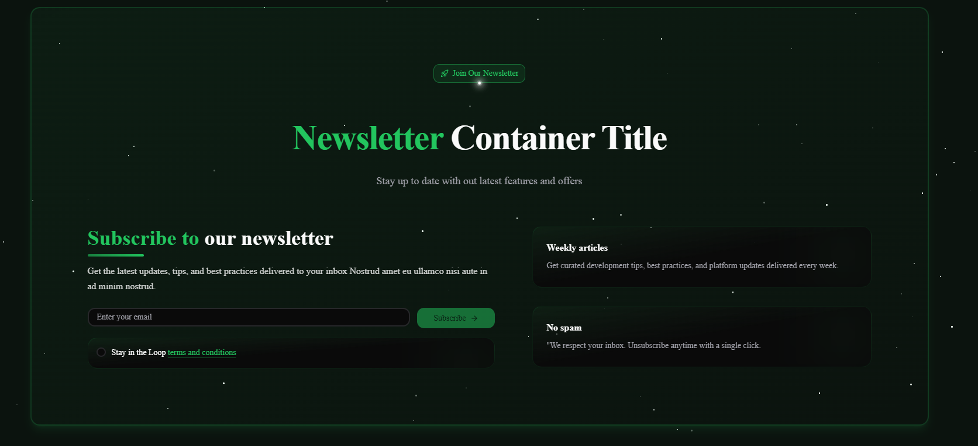
This requires a logical thought process to re arrange the following components to re align horizontally and vertically within the new container.
Considerations:
There customisations to elements of each component that can be applied via options set in the fields in strapi
- Section Header
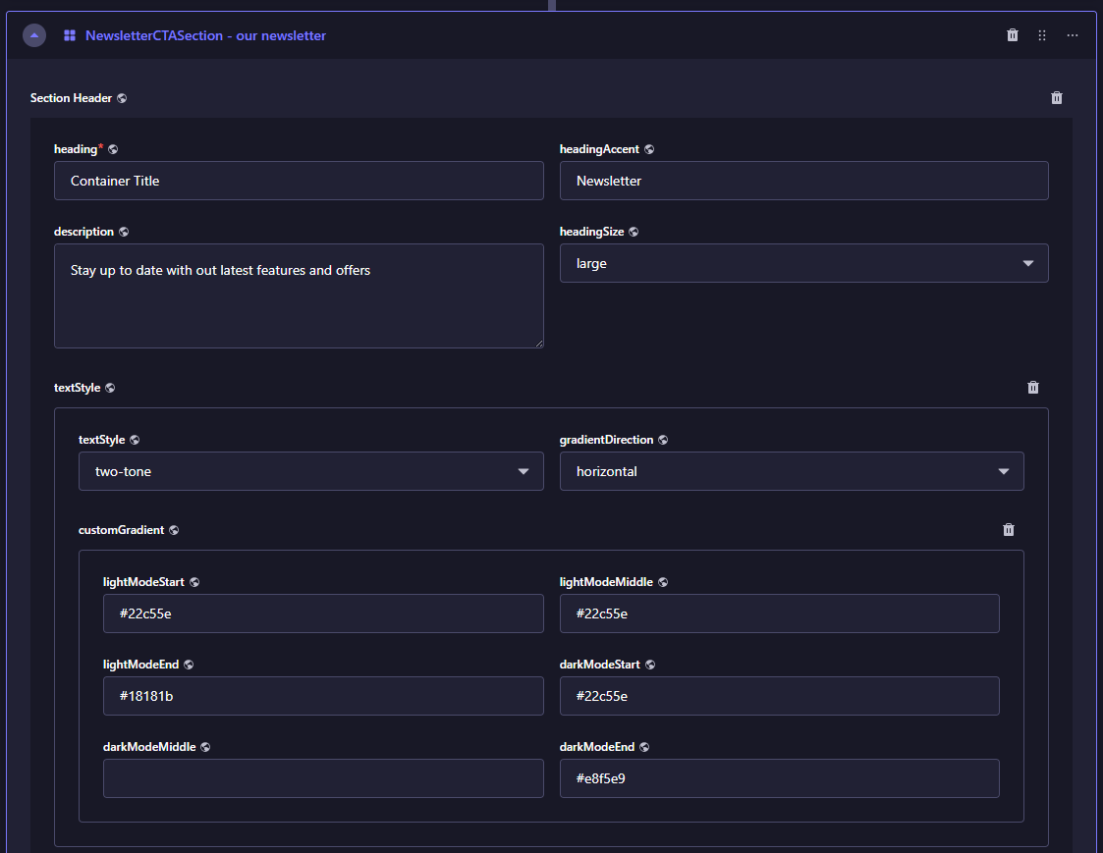
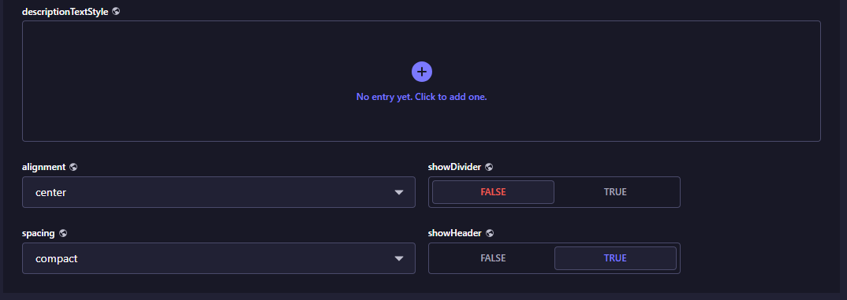
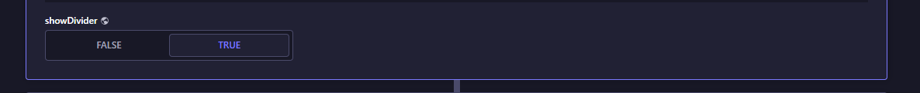
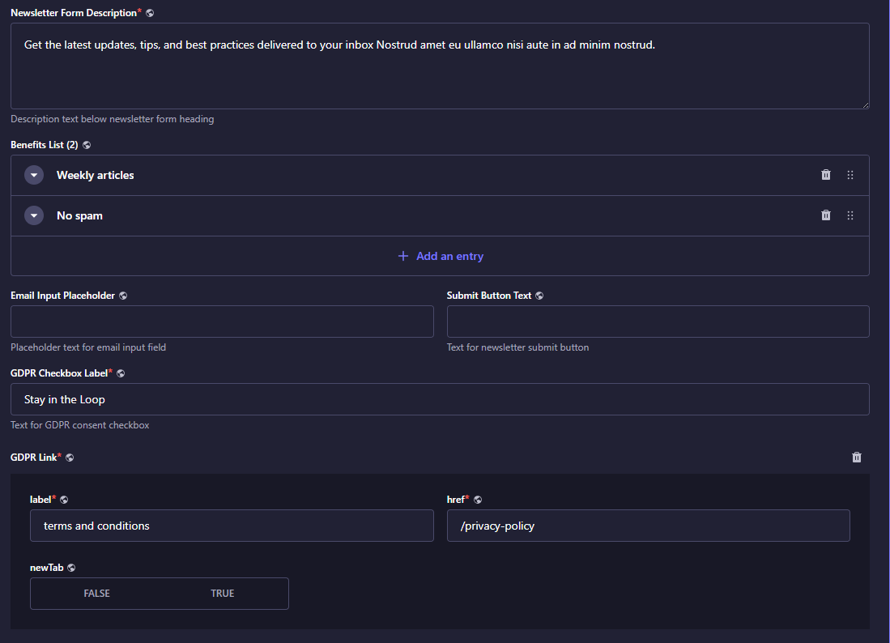
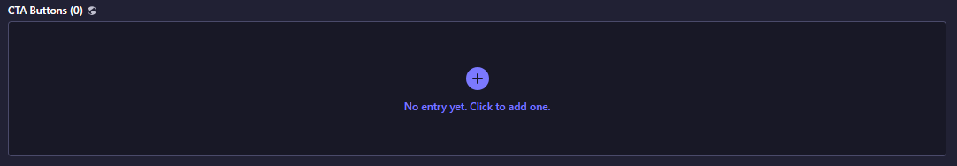
Section: backgroundStyle
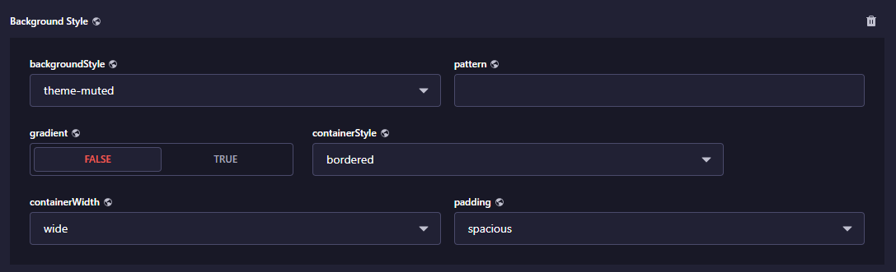
2: Badge
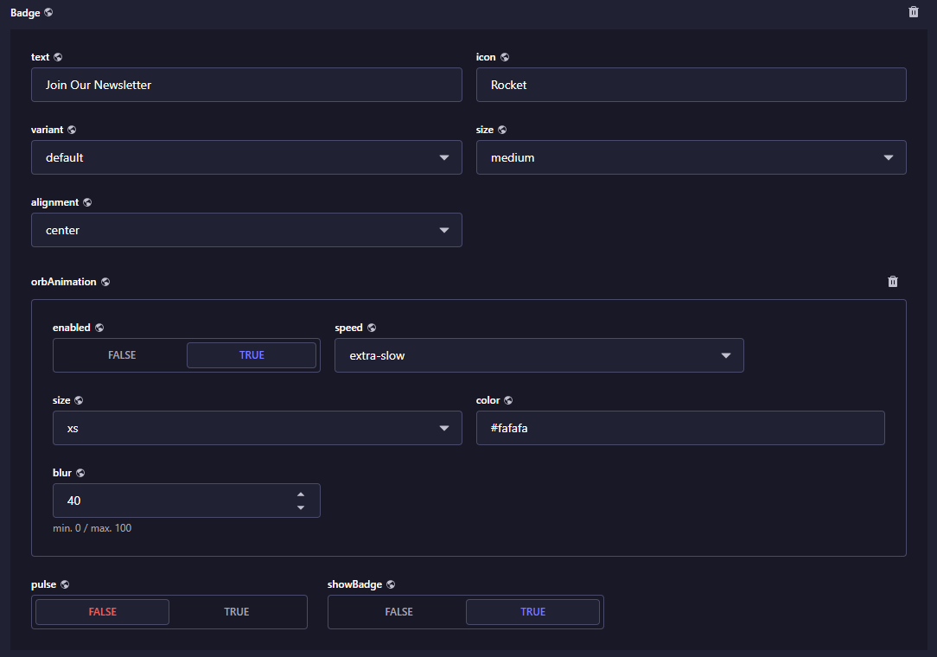
For full customisation do a deep review of strapi for settings and options for components
- Badge
- Section Heading
- Description
- Component

Options: that will affect alignment
- Size
  - Small
  - Medium
  - Large

- Padding
  - Default
  - Compact
  - Spacious

- Alignment
  - Left
  - Centre
  - right

- divider for the heading component will affect alignment

- setting to headings in the section and in the components work independently of each other, but have the options they have set

Should be evenly displayed vertically and horizontally throughout every break point in a fluid capacity, without snapping into place.
- Containers Queries
- Flexbox
Media Queries
I think with a true to level refresh and look at our goal, understand the atomic structure, and refine it to truly utilise Atomic Design, will help us reach our goals in a consistent pattern and way to implement across any section in the application. Its not just about the StrapiNewsletterCTASection, but every section that we put a component in to have thos customisations available to them.
Also we have created a lot of documentation around this, so don’t follow it but consider the all the the thing we learnt from it the pit falls etc so when considering our next steps from section down you wil see our problems.
No quick fixes this is the process to move on at speed
We are going to look at all the work we done on the newsletter, and how we can start again with the new plan in mind to build out a sect that has the StrapiNewsletterCTASection component in.
Not time for coding, its time to go back to the data and professionally review the structure and provide production grade Atomic Design the best way possible to utilise the data on the frontend. If something don’t work on the frontend, first stop, it’s the data and its structure we analyse first, nesting, relations etc, does it need breaking down more, to better utilise it on the frontend, managing complexity and documenting the process to automate for future components
Have a good think about it as after over 10 hours we have to do better and be more productive, which comes with slowing down truly thinking about it with a strict ethos of ethos to maintainable, scalable and eventually testable methodology.
It all starts with the backend, what do you think.
Remember NO CODE, review and talk, and plan together, because caring on in this way will lead to pure hardship for any client moving forward, leading to latency among many other hardships

Production Ready backend, that’s maintainable, scalable and eventually testable, so we work with that in mind/

